Year 5 Team building and Adventure day 2022
Every year, Year 5 end their first block of the PE curriculum (team building and social skills) with a day in their tutor groups. We go to Burrington Coomb and enlist the expertise of those at Mendip adventure to take them for half a day of team building challenges and half a day caving.
Students get the chance to show skills that they have learnt throughout the term and challenge themselves and fellow tutees further.
It is a great trip that enriches the students to face their fears and overcome barriers.
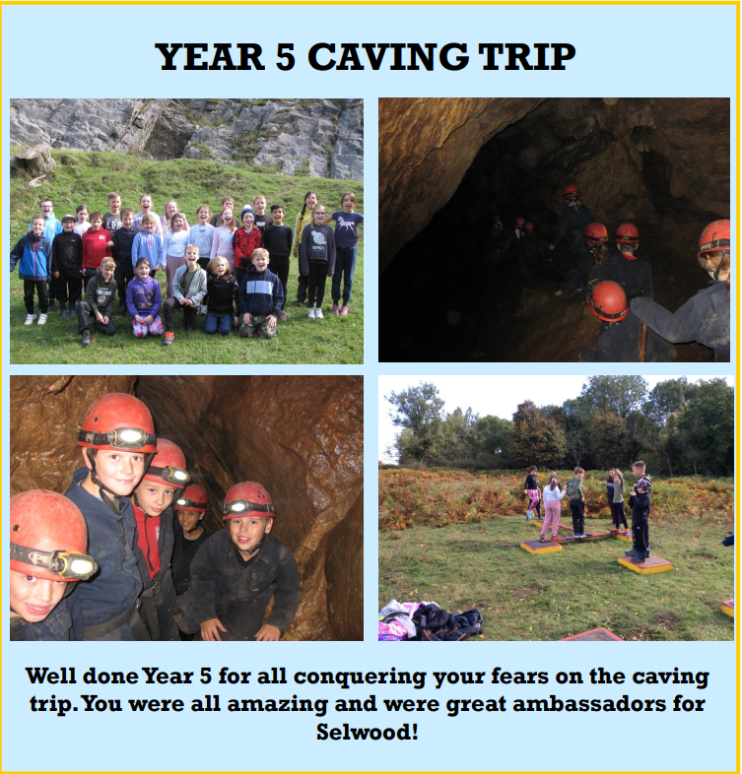
Year 6 Outdoor and Activity residential trip
At the end of year 6 and as part of the departments outdoor and adventurous activity programme, we invite all students to take part in a three-day residential trip to the Mendips.
The students take part in a number of activities that can included rock climbing, abseiling, water sports, team building games to name a few.
The students benefit from staying away from home often for the first time in their lives. The camp in tents to enable them to gain the full experience of outdoor living. All food is catered for and students have a lifelong memory to cherish.
